Shane Riegodedios

Dr. Amtof

Introduction to Algorithm Analysis

20 April 2017

1.)

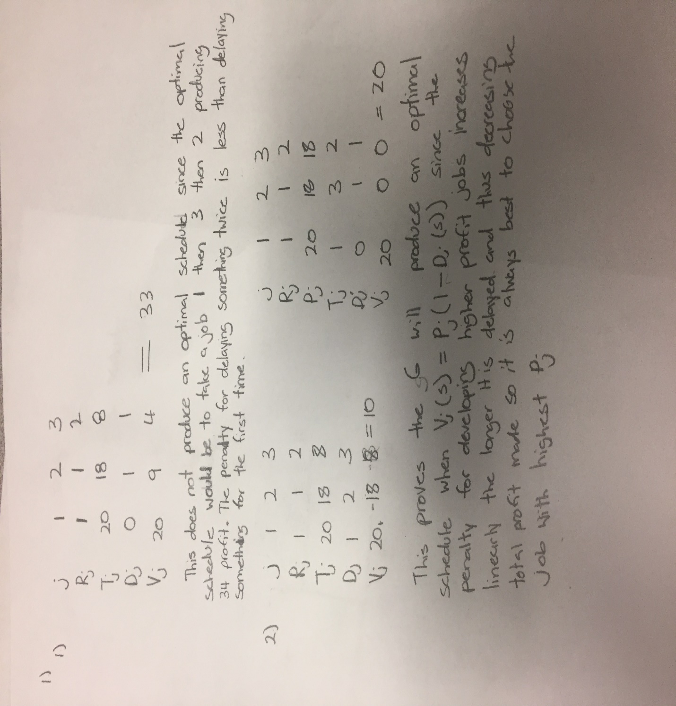

2.)

